New Compare Multiple Schemas
As you may have noticed in 12.11, the Compare Schemas window got a facelift. The new window is easier to use and better looking, but it still has the same powerful schema compare and sync technology doing the work in the background. As a part of that simplification, the new Schema Compare window only compares a single source and target schema. If you want to compare one schema to multiple, you can find the Legacy Schema Compare window in the menu customization area to resurrect it.
Now, in 12.12, “Compare Multiple Schemas” looks a lot like the new 12.11 “Compare Schemas” window, except it gives you the ability to perform various kinds of multiple schema comparisons.
The different kinds of comparisons you can do are:
- One:one – compare a source schema or snapshot file to a target schema or snapshot file
- One:many – compare a source schema or snapshot file to multiple target schemas
- Many:many Schemas – compare one or multiple pairs of schemas in a source and target database
- Many:many Snapshots – compare multiple pairs of snapshot files.
Here are some quick links to the sections of this document
- Object Types – select which object types to compare.
- Options
- Object Type Specific Options such as data type precision, whitespace in code, etc.
- Storage clause
- Output
- Script options
- Filters on object names to be compared
- Compare and Review

This is what the window looks like when you first open it.
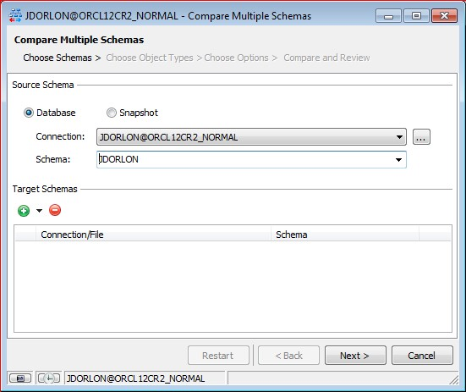
One:one
To add a single schema, click the “+” button, and you’ll see this dialog.
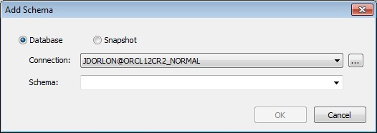
You can’t compare a schema to itself, so it’s not possible to choose the source schema as a target schema. Choose another schema or snapshot file and click OK. You can add as many target schemas as you want by repeating this step.

One:many
There are a couple ways to set up one:many comparisons. One is to just click the “+” button to add as many target schemas as you want, one at a time.
If you want to add multiple target schemas in one go, click “Add multiple schemas” in the dropdown.
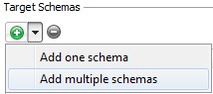
Then you’ll see this dialog.
To choose the same schema from multiple databases, choose the connections below and then click OK.
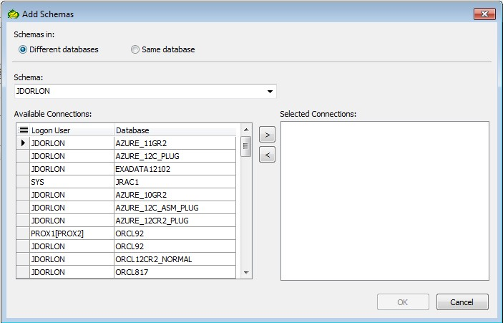

On the other hand, you may wish to choose multiple schemas from a single database. If so, click “Same database”, then choose your target schemas from that database, and click OK.
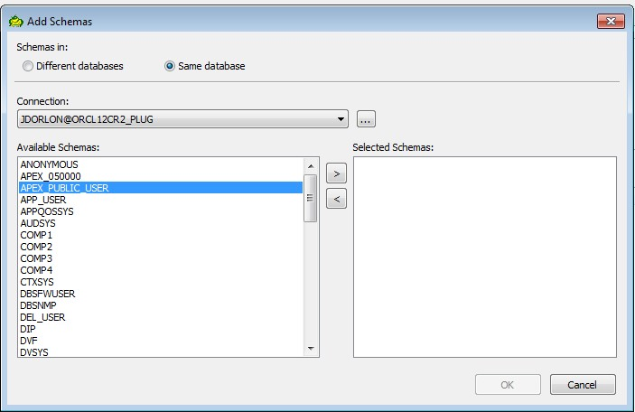

Many:Many Schemas
This is where the functionality of the old “Compare Multiple Schemas” window from 12.11 and prior comes in.
To compare pairs of schemas in a source and target database, choose “<Multiple Schemas>” in the “Source Schema” dropdown in the main window. 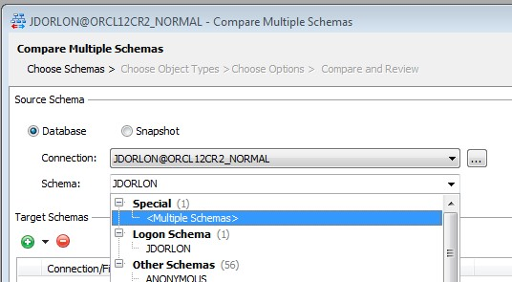

This will cause the bottom ½ of the window to change for this style of schema selection. (next page).

“Match schema names automatically” means that you don’t have to manually pick the schemas to compare. Toad will automatically match them up by name when you run the comparison. Built-in schemas like SYS, SYSTEM, ORDSYS, etc, will be excluded (Look for “MultipleSchemasToIgnore” in Toad.ini if you want to edit the list of schemas that Toad will ignore). If you want to get an idea of which schemas will be compared, uncheck the “Match Schemas Automatically” box and they’ll be displayed below. Then you can re-check the box to revert back to automatic.
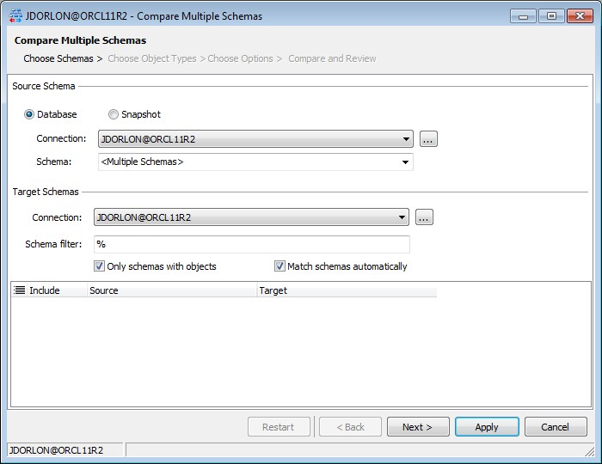

To manually choose the schemas to compare, uncheck “Match Schemas Automatically”. Toad will display the schemas found in the Source and Target Connections, and it will check the ones it finds that exist in both schemas. You can change the “Target” schema if you want to match a source to a schema by a different name, and you can check/uncheck in the “Include” column to indicate which schema pairs to compare.
In either cause (automatic or manual), you can use the “Schema filter” box to match the schemas to a particular pattern. For example, in the screenshot below, I could change the filter to “COMP%” to only compare the schemas that begin with the letters COMP.
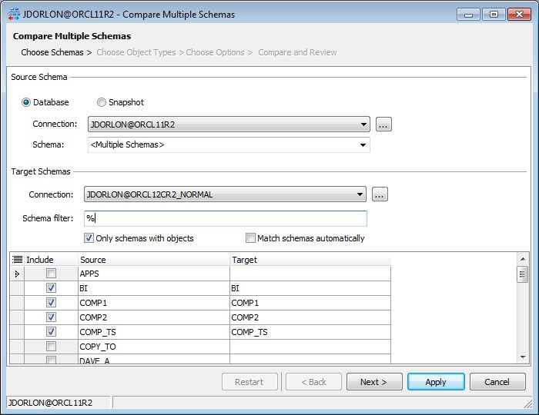

Many:Many Snapshots
To compare multiple sets of snapshot files, choose “Snapshot” as the source schema, and then “Multiple Files” in the “Snapshot file” dropdown. The GUI will change for multiple snapshot file selection as shown below.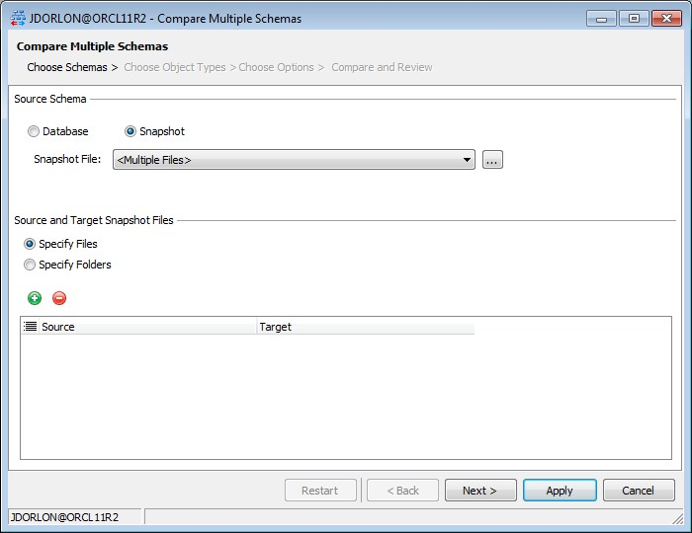
Click the “+” button to add a pair of snapshot files to the comparison. This dialog will appear. You can click the “+” button again to add another pair of snapshot files.
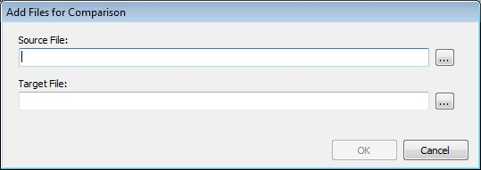

Alternatively, if all of your source files are in one folder and all of your target files are in another folder, and the pairs of files to be compared have the same file names, check “Specify folders” and then specify the source and target folders in the edit boxes shown below.
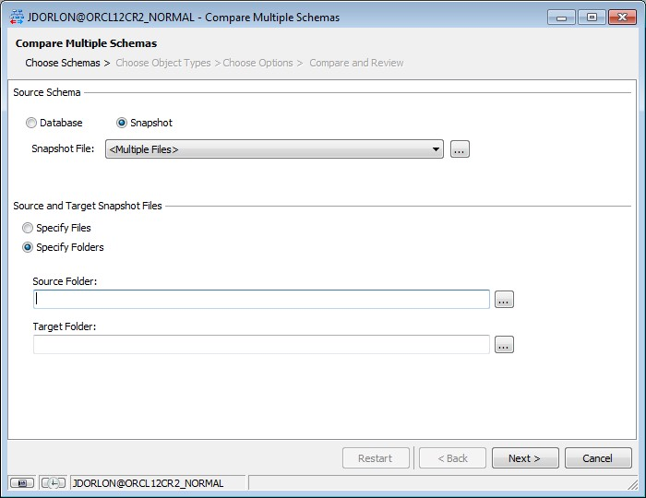

Object Types
After you’re selected your schemas to compare, click “Next” to get to the step where you choose which object types to compare. I really don’t have much to say about it. You can right-click to check all/none if you want. Check the object types that you want to compare and click “Next”.
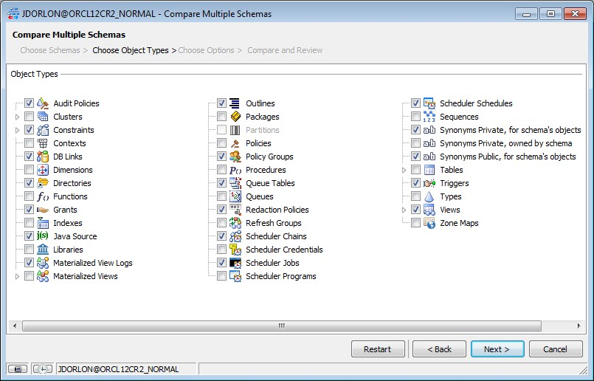

Options
The options step starts off with what we think are some pretty good defaults. If looking at them makes your eyes glaze over, just click “Next”.
Object Type Specific Options
Here you can get picky about what to compare and what to ignore for each object type. Some of the options, when selected, will show a description off to the right.
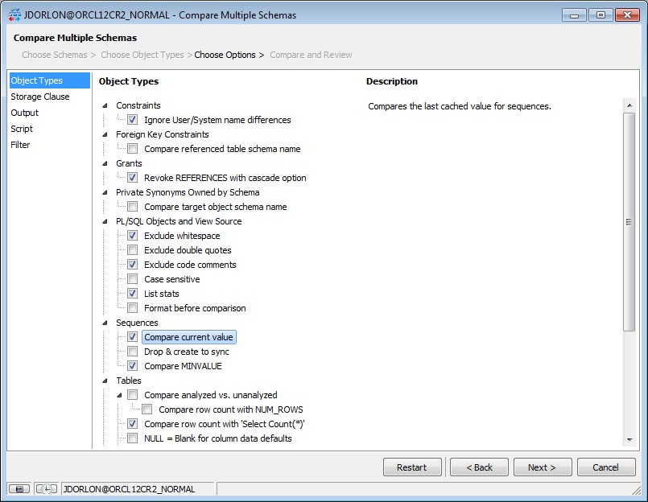

Storage Clause Options
These apply to any type of object with storage. You can compare or ignore the entire storage clause, or choose which parts of it to compare. If a certain property is ignored and an object with storage has to be created, then that property will not appear in the storage clause of the Create statement, so Oracle will use the default value.
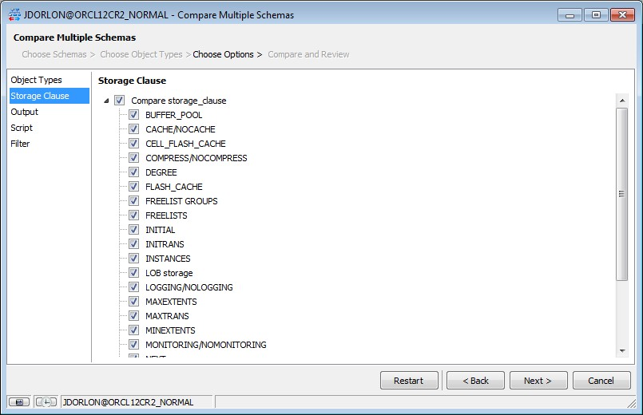

Output
If the comparison is run interactively – that is, from this window, and not as an action with no GUI in the automation designer, then output is optional and can be saved later. However, with multiple comparisons, it is more convenient to configure output than to save the files later.
Toad will create subfolders for each compared pair of schemas, in the Base Output Folder. So you don’t have to specify any file names, just specify the Base Output Folder and then choose what types of output that you want to be saved to it.
In the screen shot below, the various “File” outputs are disabled because nothing is chosen yet for a Base Output Folder. Once the folder is selected, the “file” checkboxes will become enabled. The Snapshot File checkboxes are only enabled when the schema being compared is from a live database, not a snapshot file.
Output can be emailed without being saved to file. Some email configuration is required in Toad’s main options window.
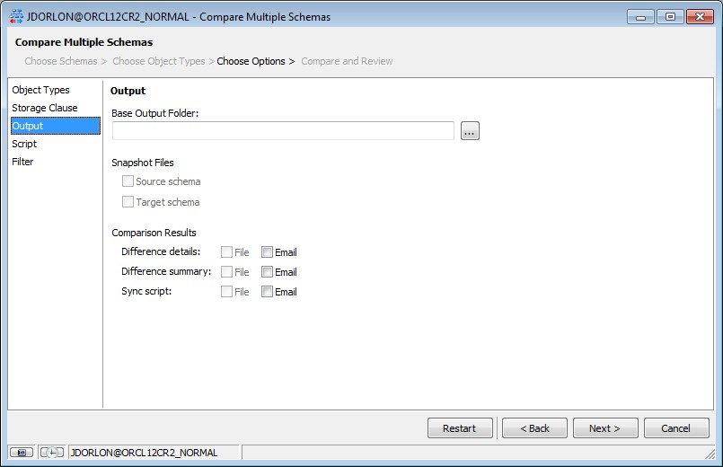

Script Options
Just a few options here about what to include in the script. Some of them will show a description when clicked.
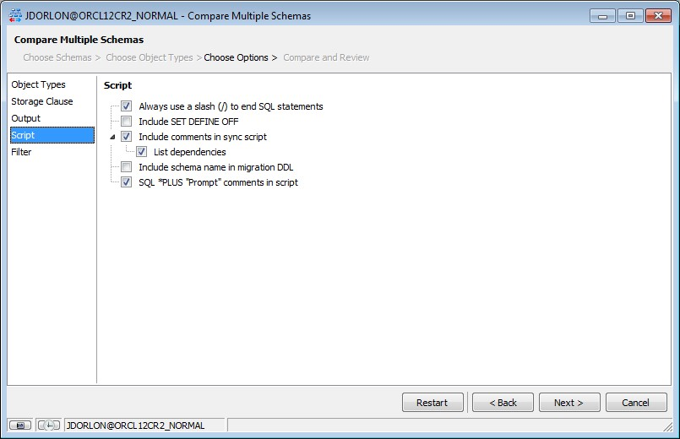

Filter
Everything on this step is optional.
Compare Object Names – use this to only compare objects that have a name which matches (or does not match) the pattern you supply
Maximum number of differences – comparison will stop if this number of differences is found in a pair of schemas.
Exclude File – can be used to prevent certain objects from appearing in the sync script (details on how to create an exclude file are given in the “Compare and Review” section.
Object Set – can be used to specifically list which objects are to be compared. If no objects of a particular type are listed here, then all objects of that type will be compared. For example, suppose you selected both “Tables” and “Views” in “Object Types”, and in the Object Set grid below, you added 3 tables. Of all the tables in the schema, only those three will be compared. Since you didn’t specify any views in the Object Set, all views in the schema will be compared.
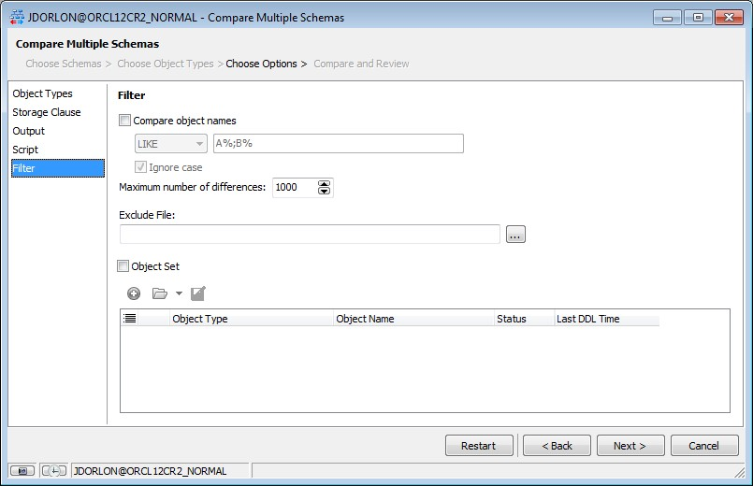

Compare and Review
When you get to this step, the schemas or snapshot files to be compared should be listed at the top of the window. To begin the comparison, click the green triangle. As the comparison proceeds, status is given on the line in the grid for that pair of schemas.
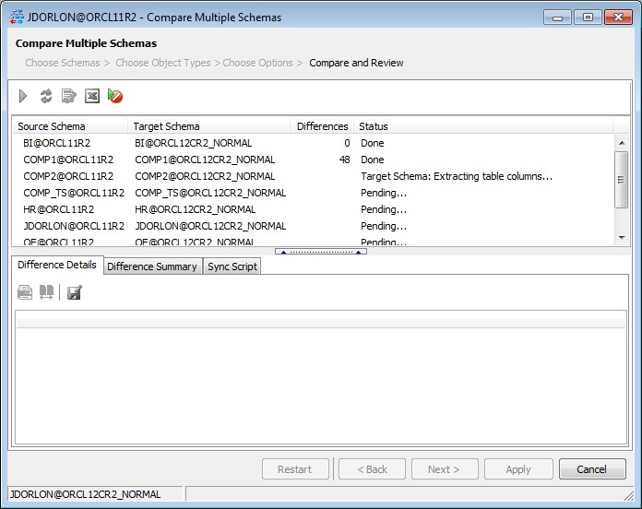

When comparison is complete, the bottom ½ of the window is with results for the selected pair of schemas in the top.
The right-click options in the “Difference Details” tab are the same as there were in Toad’s Legacy Schema Compare, so there is lots of power there. To exclude something from the sync script, just uncheck it. (Note, this does not automatically re-save the sync script, you’d have to do that manually after making changes).
To create the “Exclusion File” that I mentioned in the “Filters” section, uncheck the objects that you want to exclude, and then right-click and choose “Create Exclusion File from unchecked items”. A file will be produced based on your selection, and the file contains further instructions on how to edit it (which is optional).
To quickly find a particular object in the Difference Details, click CTRL+F on your keyboard and you will be presented with a filter dialog. Hit ESC to undo the filter.
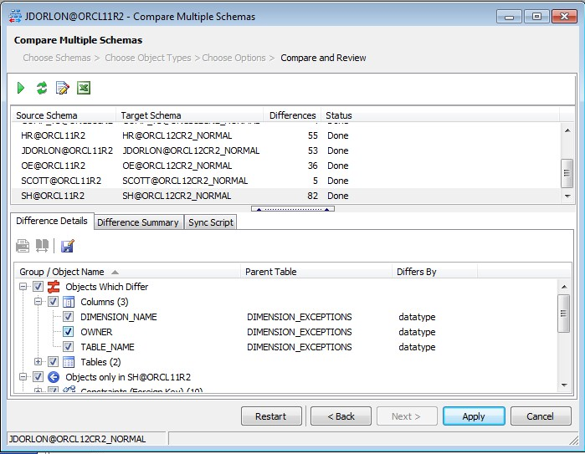
Now, one thing this window does differently than its predecessors, is spool each pair of source/target schemas to a temp file, and reload it as you click from one row to the next in the top ½ of the window. The reason for this is to conserve memory if lots of schemas are being compared. This is especially important in the many:many comparisons, where we have a different source schema for each comparison.
For small schemas, the time to reload the schemas from temp files is very short, but it takes a few seconds on the larger schemas.

